Before we start:
http://www.javapractices.com/topic/TopicAction.do?Id=122

Buffering Advanced
===============================================================

To start this activity, have one team member make a copy of this document and share with the rest of the team members present in the workshop.
This will give your team a copy to edit as you are working through the activity steps.

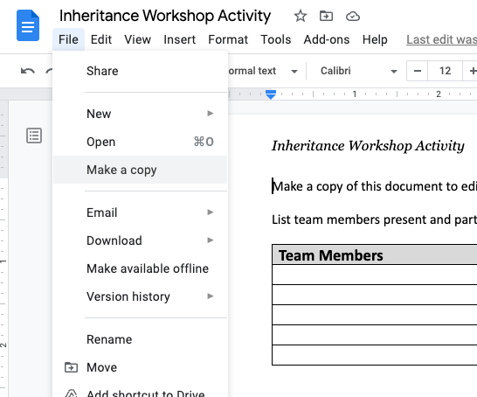

List team members present and participating in this activity:

Team Members

Part 1- Variable names
In the past, we have typically saved objects to variables as soon as we created them.

World world = new World();
Turtle turtle1 = new Turtle(world);

However, it is also reasonable to use them as soon as we create them.

Turtle turtle2 = new Turtle(new World());

Later .. Critical Thinking Questions

- Open the Main class and add the above code to the main method under the first To Do comment. Run and compare both code segments:
  - In the first code segment, which object is created first (the World or the Turtle)?

  - In the second code segment, which object is created first (the World or the Turtle)?

- Explain why a World object is needed for creating a Turtle object.

- Copy the last line of the first code segment to create a third Turtle. Copy the second code segment to create a fourth Turtle.
  - Besides color, how do your third and fourth Turtle objects differ?

  - Summarize in your own words, the disadvantage of not naming the World variable.

- Consider the Scanner class.
  - Give a line of code that creates a Scanner object to read from a keyboard.

  - Explain why it’s important to save this Scanner object to a variable.

  - Would you consider reading from the keyboard as input or output?

  - Give an example of the opposite (input or output) in a typical program.

- Now let’s examine the Java API for System and Scanner.
  - What class type is System.in?System (Java SE 12 & JDK 12 )

  - Which Scanner constructor is being called by your code in the previous question (CTQ 4a)?

  - To create a Scanner object using the first Scanner constructor listed in the API, what type of object do you need?

  - Click on the parameter in the first Scanner constructor listed in the API, and scroll down to its constructors. How many constructors are there for this class?

- Assume you have a String argument called filename. Give the code that uses the first Scanner constructor listed in API (one of the constructors you identified for CTQ 5d) and saves the result to a variable.
File inputFile = new File(filename);

- Now give the code that uses the variable you defined in the previous question to create a Scanner object.
Scanner scan = new Scanner(inputFile);

- Assuming your code for the previous two CTQs look like the first code segment in this Model, create another Scanner object following the second code segment in this Model. If your code looks like the second code segment, create a Scanner object that looks like the first code segment.
Scanner scan = new Scanner(new File(filename));

Part 2 - File Readability

Instead of reading input from a keyboard (System.in), we can read input from a file.
Instead of writing output to the monitor (System.out), we can write output to a file.

Program
DVD
Keyboard
Monitor
Hard disc
Input stream
Output Stream
A Java program can create two different types of files: a text file and a binary file. Your answer to the last question in the previous Model (CTQ 8) opens a text file and creates a Scanner object that will read input from that text file.

This zip file has an example of a text file (code.txt) and a binary file (file.bin). Download both the example files. Then spend no more than five minutes on the next two questions.

Critical Thinking Questions

- Try opening the text file with at least three different programs on your computer. Give examples of different programs that were able to read the text file.

- Now try opening the binary file in at least three different programs on your computer. Describe what you see when you open the binary file.

- Consider how a Java program reads input from the keyboard.
  - Give three methods from the Scanner class that you use to read input from the keyboard.

  - Can you use the Scanner class to read a word twice from the keyboard?

  - If so, give the code that will allow that to happen. If not, explain what your program should do to use that word multiple times.

  - When mixing Scanner methods in a program (i.e., calling different methods consecutively), which Scanner method will appear to read nothing from the keyboard if following another Scanner method? (If you can’t remember, uncomment the code under Part 2 in the Main method and try it out)

- Consider what happens when your Java program writes output to the monitor.
  - Give two methods that you use to write output.

  - Can you write a paragraph, and then go back to add a sentence before the paragraph?

- Examine your code from the last CTQ from the previous Model (CTQ 8), which created a Scanner object to read input from a text file. In the main method type the code to read the text file “code.txt”.
  - Give the code to create the Scanner object that reads from the text file (Screenshot is fine too).

  - Give the code that reads the first five lines of the text file (Screenshot is fine too).

  - What happens if you create a second Scanner object from the same text file and use the second Scanner object to read a line? Does it start where the first one left off, or does it start at the beginning of the file again? Try it out and add a screenshot

  - There are 15 lines in the text file. What happens if you write code that tries to read 16 lines from the text file? Try it out and add a screenshot

- To write output to a text file, you will need to create a PrintWriter object, which takes a String as an argument (the filename). The PrintWriter class uses the same two methods you identified in CTQ 12a to write text to a file.
  - Give the line of code that would create a PrintWriter object.

  - Give a line of code that should print “hello world” in your text file. (Don’t be concerned if this does not appear to work.)

  - What happens to your original text file if you create a PrintWriter object using the same filename you used to create a Scanner object?

Group Reflection:

Answer the following three questions:
- What Java classes should you use to read from a text file?
- What Java class should you use to write to a text file?
- Give one reason why a Java program would want to write to a text file (instead of writing to System.out).

